IMAP/POP3 Server – Mail Access

📬 What Is an IMAP/POP3 Server – Mail Access Component?
# Source: Chatgpt (GPT-5-Mini) at [1/21/2026]
An IMAP/POP3 server is part of a mail server system that allows email clients (like Outlook, Thunderbird, Apple Mail, or Gmail) to access messages stored on the mail server.
It handles how users read, download, or sync their emails from the server to their device.

🧠 Why Is It Needed?
# Source: Chatgpt (GPT-5-Mini) at [1/21/2026]
Mail is usually stored on the server after it arrives (via SMTP). But users need a way to access that stored mail — this is where IMAP or POP3 servers come in.

📦 Two Protocols – What's the Difference?
# Source: Chatgpt (GPT-5-Mini) at [1/21/2026]
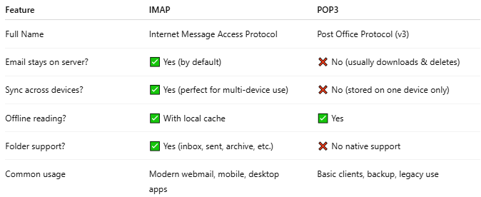

Feature | IMAP | POP3
Full Name | Internet Message Access Protocol | Post Office Protocol (v3)
Email stays on server? | ✅ Yes (by default) | ❌ No (usually downloads & deletes)
Sync across devices? | ✅ Yes (perfect for multi-device use) | ❌ No (stored on one device only)
Offline reading? | ✅ With local cache | ✅ Yes
Folder support? | ✅ Yes (inbox, sent, archive, etc.) | ❌ No native support
Common usage | Modern webmail, mobile, desktop apps | Basic clients, backup, legacy use

🧰 Examples of IMAP/POP3 Server Software
# Source: Chatgpt (GPT-5-Mini) at [1/21/2026]
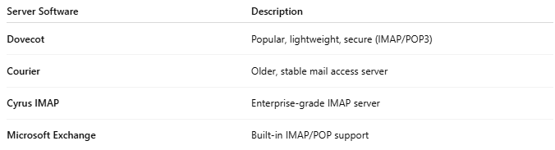

Server Software | Description
Dovecot | Popular, lightweight, secure (IMAP/POP3)
Courier | Older, stable mail access server
Cyrus IMAP | Enterprise-grade IMAP server
Microsoft Exchange | Built-in IMAP/POP support

📍 How It Fits Into the Email System
# Source: Chatgpt (GPT-5-Mini) at [1/21/2026]
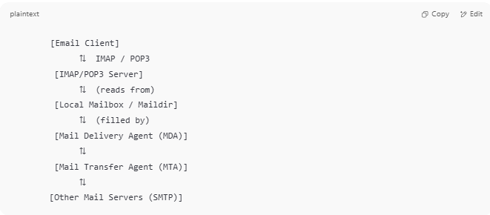

[Email Client]
⇅ IMAP / POP3
[IMAP/POP3 Server]
⇅ (reads from)
[Local Mailbox / Maildir]
⇅ (filled by)
[Mail Delivery Agent (MDA)]
⇅
[Mail Transfer Agent (MTA)]
⇅
[Other Mail Servers (SMTP)]

✅ Summary
# Source: Chatgpt (GPT-5-Mini) at [1/21/2026]
The IMAP/POP3 server is the component that lets email clients access and download messages from the mail server.
- IMAP = syncs across devices, leaves mail on server
- POP3 = downloads and removes mail from server

